First, summary statistics of key variables.

Dependent variables:
"total_program_expenses",
"total_revenue"

Explanatory variables:
"donation_revenue",
"fundraising_revenue",
"government_revenue",
"membership_revenue",
"investment_revenue",
"other_revenue",
"state_real_gdp" (not included in summary)

Categorical variables / Fixed effects:
"organization_ein",
"organization_name",
"state",
"industry",
"year"
Descriptive Statistics for Selected Variables
Variable | Description | Observations | Mean | Std_Dev | Min | Max
donation_revenue | Revenue from campaigns and direct donations. | 2,949,542 | 8,865.129 | 352,339.5 | 0 | 127,014,579
fundraising_revenue | Revenue from fundraising events. | 2,949,542 | 30,132.644 | 844,187.2 | 0 | 350,002,158
government_revenue | Revenue from government grants. | 2,949,542 | 593,515.372 | 15,740,337.2 | 0 | 11,069,708,938
investment_revenue | Net income from investments. | 2,949,542 | 39,564.275 | 1,447,650.5 | 0 | 717,215,986
membership_revenue | Revenue from membership dues. | 2,949,542 | 43,299.008 | 865,631.2 | 0 | 163,320,095
other_revenue | Miscellaneous revenue from other sources (i.e. sale of property, etc.). | 2,949,542 | 138,083.502 | 4,474,410.4 | 0 | 2,366,107,467
total_program_expenses | Total expenses directed towards programs. Represents the demand for the organization's services. | 2,949,542 | 6,479,512.553 | 148,938,775.5 | 0 | 71,256,037,114
total_revenue | Total revenue from all sources. Represents the supply of the organization's services. | 2,949,542 | 8,878,275.384 | 172,848,191.5 | 0 | 75,101,306,911
industry | Primary activity/industry category. | 26* |  |  | A | Z
organization_ein | Unique identifier (Employer Identification Number). | 456,913*
organization_name | Name of the non-profit organization. | 613,189*
state | State where the organization is located. | 50*
year | Tax year of the filing and GDP record. | 15* |  |  | 2009 | 2023
* Observations for categorical variables represent unique counts.

Then, preliminary results.

Demand Side Model:
$$log\left(Program_Expenses\right)=β{GDP_Change_Percent}_{state,year}+α_{state}+γ_{year}+τ_{industry}+ω_{organization_ein}+ε$$

Supply Side Model:
$log\left(Total_Revenue\right)=β{GDP_Change_Percent}_{state,year}+α_{state}+γ_{year}+τ_{industry}+ω_{organization_ein}+ε$

Revenue Controlled Model:
$$log\left(Program_Expenses\right)=β{GDP_Change_Percent}_{state,year}+β{\log{(Total_Revenue)}}_{state,year}+α_{state}+γ_{year}+τ_{industry}+ε$$

Preliminary Results: Non-Profit Economic Cycle (Demand-side vs. Supply-side)
 | Demand Side (Macro) | Supply Side (Macro) | Demand Side (Industry) | Supply Side (Industry) | Demand Side (Firm) | Supply Side (Firm) | Revenue Controlled
GDP Change % | -0.007** | -0.003+ | -0.005* | -0.003 | 0.007*** | 0.007*** | -0.002
 | (0.002) | (0.002) | (0.002) | (0.002) | (0.001) | (0.001) | (0.002)
Log(Revenue) |  |  |  |  |  |  | 0.832***
 |  |  |  |  |  |  | (0.000)
Num. Obs. | 2949542 | 2949542 | 2949542 | 2949542 | 2885825 | 2885825 | 2949542
R2 | 0.049 | 0.090 | 0.154 | 0.123 | 0.847 | 0.844 | 0.597
FE: year | X | X | X | X | X | X | X
FE: state | X | X | X | X | X | X | X
FE: industry |  |  | X | X | X | X | X
FE: organization_ein |  |  |  |  | X | X
+ p < 0.1, * p < 0.05, ** p < 0.01, *** p < 0.001
Demand Side (Macro-Economic Fixed Effects): This regression shows that for a 1-unit increase (1% increase) in real GDP change, non-profit program expenses decrease by 0.7%. This result is significant at the 99% confidence level (p < 0.01).
Supply Side (Macro-Economic Fixed Effects): This regression shows that for a 1-unit increase (1% increase) in real GDP change, total revenue decreases by 0.3%. This result is significant at the 90% confidence level (p < 0.1).
Demand Side (Industry Fixed Effects): This regression shows that for a 1-unit increase (1% increase) in real GDP change, non-profit program expenses decrease by 0.5%. This result is significant at the 95% confidence level (p < 0.05).
Supply Side (Industry Fixed Effects): This regression shows that for a 1-unit increase (1% increase) in real GDP change, total revenue decreases by 0.3%. This result is not statistically significant.
Demand Side (Firm Fixed Effects): This regression shows that for a 1-unit increase (1% increase) in real GDP change, non-profit program expenses increase by 0.7%. This result is significant at the 99.9% confidence level (p < 0.001).
Supply Side (Firm Fixed Effects): This regression shows that for a 1-unit increase (1% increase) in real GDP change, total revenue increases by 0.7%. This result is significant at the 99.9% confidence level (p < 0.001).
Revenue Controlled: This regression shows that for a 1-unit increase (1% increase) in real GDP change, non-profit program expenses decrease by 0.2%. This result is not statistically significant. However, for a 1-unit (1% increase) in total revenues, non-profit program expenses increase by .83%. This result is significant at the 99.9% confidence level (p < 0.001).

Then discussion of the economic relevance / importance of the preliminary results. Transition to why explanatory variables are needed to better strengthen the effect / correlation.

Then, explanatory variables experiment. Show the specific forms of revenue that are affected by the cyclical effect.
Revenue Source Model(s):
$$log\left([Revenue_Source]\right)=β{GDP_Change_Percent}_{state,year}+α_{state}+γ_{year}+τ_{industry}+ε$$

Cyclicality of Non-Profit Revenue Sources (Industry & State FE)
 | Donations | Fundraising | Govt Grants | Membership | Investment | Other
GDP Change % | -0.005*** | 0.004** | -0.012*** | -0.002 | -0.003* | -0.007***
 | (0.001) | (0.001) | (0.002) | (0.002) | (0.001) | (0.002)
Num. Obs. | 2949542 | 2949542 | 2949542 | 2949542 | 2949542 | 2949542
R2 | 0.034 | 0.038 | 0.102 | 0.085 | 0.069 | 0.039
FE: year | X | X | X | X | X | X
FE: state | X | X | X | X | X | X
FE: industry | X | X | X | X | X | X
+ p < 0.1, * p < 0.05, ** p < 0.01, *** p < 0.001

Donations: This regression shows that for a 1% increase in GDP change, donations revenue decrease by 0.5%. This result is significant at the 99.9% level (p < 0.001).
Fundraising: This regression shows that for a 1% increase in GDP change, fundraising revenue increases by 0.4%. This result is significant at the 99% level (p < 0.01).
Government Grants: This regression shows that for a 1% increase in GDP change, government revenues decrease by 1.2%. This result is significant at the 99.9% level (p < 0.001).
Membership revenues did not show significant correlations in this model.
Investment: This regression shows that for a 1% increase in GDP change, investment revenues decrease by 0.3%. This result is significant at the 95% level (p < 0.05).
Other Revenue: This regression shows that for a 1% increase in GDP change, miscellaneous revenue decreases by 0.7%. This result is significant at the 99.9% level (p < 0.001).

Revenue Source Model(s) with firm fixed effects:
$$log\left([Revenue_Source]\right)=β{GDP_Change_Percent}_{state,year}+α_{state}+γ_{year}+τ_{industry}+ω_{organization_ein}+ε$$

Cyclicality of Non-Profit Revenue Sources (Organization FE)
 | Donations | Fundraising | Govt Grants | Membership | Investment | Other
GDP Change % | -0.000 | 0.004*** | -0.001 | 0.002** | 0.000 | -0.003*
 | (0.001) | (0.001) | (0.001) | (0.001) | (0.001) | (0.001)
Num. Obs. | 2885825 | 2885825 | 2885825 | 2885825 | 2885825 | 2885825
R2 | 0.754 | 0.704 | 0.780 | 0.859 | 0.876 | 0.712
FE: year | X | X | X | X | X | X
FE: state | X | X | X | X | X | X
FE: industry | X | X | X | X | X | X
FE: organization_ein | X | X | X | X | X | X
+ p < 0.1, * p < 0.05, ** p < 0.01, *** p < 0.001

Donations revenues did not show significant correlations in this model.
Fundraising: This regression shows that for a 1% increase in GDP change, fundraising revenue increases by 0.4%. This result is significant at the 99.9% level (p < 0.001).
Government Grants revenues did not show significant correlations in this model.
Membership: This regression shows that for a 1% increase in GDP change, membership revenue increases by 0.2%. This result is significant at the 99% level (p < 0.01).
Investment revenues did not show significant correlations in this model.
Other Revenue: This regression shows that for a 1% increase in GDP change, miscellaneous revenue decreases by 0.3%. This result is significant at the 95% level (p < 0.05).

Then, heterogeneity analysis of revenue controlled. Across revenue sizes and then industry. (though the order doesn’t matter that much). Show that not all industries nor sizes are effected in the same way.

Revenue Quintile Heterogeneity Test:
$$log\left(Program_Expenses\right)=β{GDP_Change_Percent}_{state,year}+β{\log{(Total_Revenue)}}_{state,year}+α_{state}+γ_{year}+ε$$
Split by and repeated for each quintile of Total Revenue.

Revenue Quintile | Coefficient | Std. Error | P-Value | Sig. | N
Q1 (Smallest) | 0.0004 | 0.0019 | 0.8272 |  | 589,909
Q2 (Small) | 0.0039 | 0.0036 | 0.2849 |  | 589,909
Q3 (Medium) | -0.0046 | 0.0039 | 0.2364 |  | 589,908
Q4 (Large) | -0.0087 | 0.0042 | 0.0370 | * | 589,908
Q5 (Largest) | -0.0041 | 0.0053 | 0.4346 |  | 589,908

Q4 (Large Organizations): This regression shows that for a 1% increase in GDP change, program expenses decrease by 0.87%. This result is significant at the 95% level (p < .05).
Results for Q1, Q2, Q3, and Q5 did not show statistically significant results in this model.
Image format of results:

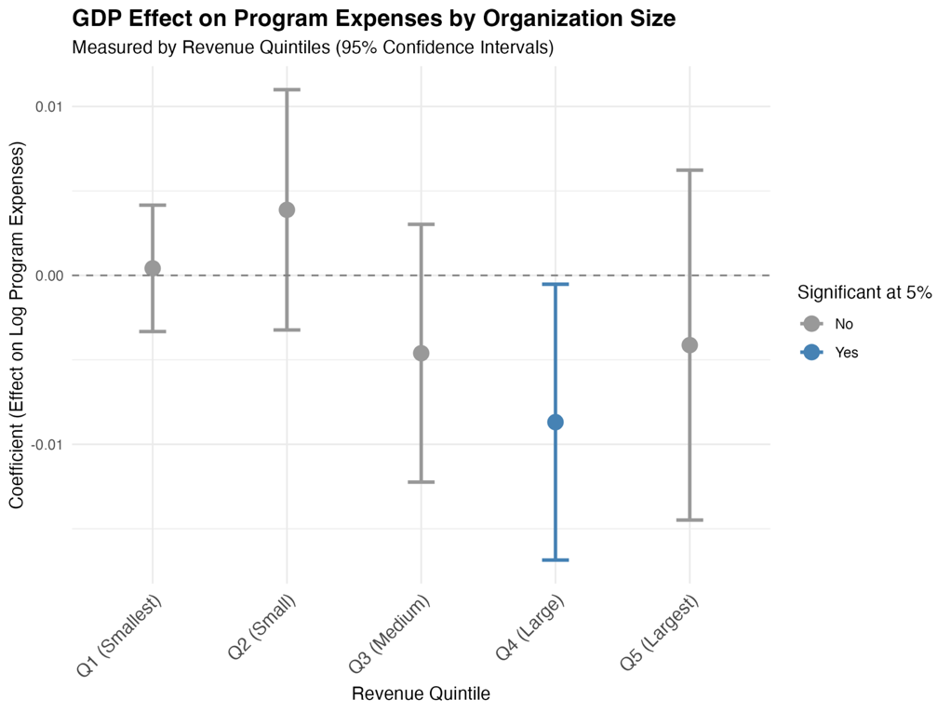

Industry Heterogeneity Test:
$$log\left(Program_Expenses\right)=β{GDP_Change_Percent}_{state,year}+β{\log{(Total_Revenue)}}_{state,year}+α_{state}+γ_{year}+ε$$
Split by and repeated for each Industry.
Industry | Coefficient | Std. Error | P-Value | Sig. | N
Science & Technology | 0.0208 | 0.0177 | 0.2407 |  | 12,939
Community Improvement & Capacity Building | 0.0119 | 0.0079 | 0.1330 |  | 261,580
Unknown or Unclassified | 0.0118 | 0.0097 | 0.2204 |  | 154,718
Recreation & Sports | 0.0115 | 0.0075 | 0.1227 |  | 199,037
Education | 0.0035 | 0.0043 | 0.4215 |  | 315,566
Crime & Legal-Related | 0.0017 | 0.0074 | 0.8125 |  | 35,149
Religion-Related | 0.0007 | 0.0044 | 0.8746 |  | 112,363
Animal-Related | 0.0003 | 0.0045 | 0.9494 |  | 60,537
Philanthropy, Voluntarism & Grantmaking | 0.0001 | 0.0046 | 0.9765 |  | 137,767
Social Science | -0.0001 | 0.0248 | 0.9977 |  | 3,768
Voluntary Health Associations & Medical Disciplines | -0.0002 | 0.0084 | 0.9811 |  | 30,416
Housing & Shelter | -0.0009 | 0.0041 | 0.8338 |  | 158,041
Public & Societal Benefit | -0.0011 | 0.0130 | 0.9347 |  | 65,257
Mental Health & Crisis Intervention | -0.0019 | 0.0045 | 0.6635 |  | 58,821
Food, Agriculture & Nutrition | -0.0027 | 0.0141 | 0.8471 |  | 38,716
Youth Development | -0.0029 | 0.0040 | 0.4735 |  | 85,201
Arts, Culture & Humanities | -0.0039 | 0.0036 | 0.2775 |  | 238,014
Medical Research | -0.0044 | 0.0212 | 0.8345 |  | 23,828
Human Services | -0.0048 | 0.0022 | 0.0307 | * | 323,231
Health Care | -0.0048 | 0.0037 | 0.1923 |  | 204,259
International, Foreign Affairs | -0.0052 | 0.0109 | 0.6329 |  | 53,345
Environment | -0.0091 | 0.0072 | 0.2074 |  | 63,958
Civil Rights, Social Action & Advocacy | -0.0116 | 0.0114 | 0.3094 |  | 29,843
Public Safety | -0.0120 | 0.0059 | 0.0431 | * | 63,776
Employment | -0.0175 | 0.0194 | 0.3667 |  | 34,752
Mutual & Membership Benefit | -0.0214 | 0.0103 | 0.0377 | * | 184,659

Human Services: This regression shows that for a 1% increase in GDP change, program expenses decrease by 0.48%. This result is significant at the 95% level (p < 0.05).
Public Safety: This regression shows that for a 1% increase in GDP change, program expenses decrease by 1.2%. This result is significant at the 95% level (p < 0.05).
Mutual & Membership Benefit: This regression shows that for a 1% increase in GDP change, program expenses decrease by 2.14%. This result is significant at the 95% level (p < 0.05).
No other industries showed statistically significant results in this model.
Image format of results:
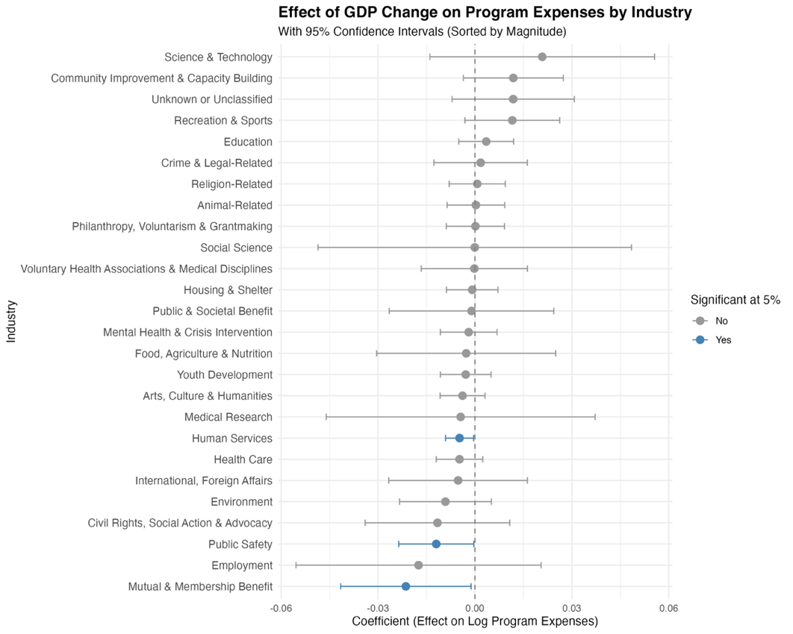

Then, end with Covid regressions. Analysis of the effect of the covid recession and difference in financial decisions (if any).
Covid Interaction Model:
$$log\left([Y]\right)=β{GDP_Change_Percent}_{state,year}+β{\log{(Total_Revenue)}}_{state,year}+β_{3}Post_Covid+β_{4}(GDP_Change_Percent *Post_Covid)+α_{state}+γ_{year}+τ_{industry}+ε$$
Expansion Interaction Model:
$$log\left([Y]\right)=β{GDP_Change_Percent}_{state,year}+β{\log{(Total_Revenue)}}_{state,year}+β_{3}Expanded_during_Covid+β_{4}(GDP_Change_Percent *Expanded_during_Covid)+α_{state}+γ_{year}+τ_{industry}+ε$$
Combined Interactions Model:
$$log\left([Y]\right)=β_{1}{GDP_Change_Percent}_{state,year}+β_{2}{\log{(Total_Revenue)}}_{state,year}+β_{3}Post_Covid+β_{4}Expanded_during_Covid+β_{5}(GDP_Change_Percent *Post_Covid) +β_{6}(GDP_Change_Percent *Expanded_during_Covid)+α_{state}+γ_{year}+τ_{industry}+ε$$

Regression Results: Covid & Expansion Interactions
 | Covid Interaction (Expenses) | Covid Interaction (Revenue) | Expansion Interaction (Expenses) | Expansion Interaction (Revenue) | Combined (Expenses) | Combined (Revenue)
GDP Change % | 0.005* | 0.019*** | -0.003 | 0.022*** | -0.001 | 0.033***
 | (0.002) | (0.003) | (0.002) | (0.002) | (0.003) | (0.002)
Log(Revenue) | 0.832*** |  | 0.809*** |  | 0.809***
 | (0.000) |  | (0.001) |  | (0.001)
GDP % × Post-Covid | -0.015*** | -0.047*** |  |  | -0.004 | -0.025***
 | (0.003) | (0.003) |  |  | (0.003) | (0.003)
Expanded Org |  |  | 0.444*** | 1.836*** | 0.444*** | 1.837***
 |  |  | (0.007) | (0.007) | (0.007) | (0.007)
GDP % × Expanded Org |  |  | 0.006** | -0.046*** | 0.005** | -0.047***
 |  |  | (0.002) | (0.002) | (0.002) | (0.002)
Num. Obs. | 2949542 | 2949542 | 2316777 | 2316777 | 2316777 | 2316777
R2 | 0.597 | 0.123 | 0.492 | 0.115 | 0.492 | 0.115
R2 Adj. | 0.597 | 0.123 | 0.492 | 0.115 | 0.492 | 0.115
FE: year | X | X | X | X | X | X
FE: state | X | X | X | X | X | X
FE: industry | X | X | X | X | X | X
+ p < 0.1, * p < 0.05, ** p < 0.01, *** p < 0.001

Covid Interaction (Expenses): This regression shows that before Covid-19 recession, for a 1% increase in GDP change, program expenses increase by 0.5%. This result is significant at the 95% level (p < 0.05). After Covid-19, a 1% increase in GDP change, is correlated with program expenses decreases by 1.5%. This result is significant at the 99.9% level (p < 0.001).
Covid Interaction (Revenue): This regression shows that before Covid-19 recession, for a 1-unit increase (1% increase) in real GDP change, total revenue increases by 1.9%. This result is significant at the 99.9% confidence level (p < 0.001). During the post-Covid period, a 1% increase in GDP is correlated with a 4.7% decrease in revenue. This interaction result is significant at the 99.9% confidence level (p < 0.001).
Expansion Interaction (Expenses): This regression shows that for a 1-unit increase (1% increase) in real GDP change, non-profit program expenses decrease by 0.3%. This result is not statistically significant. However, for organizations that expanded programming during Covid-19, a 1% increase in GDP is correlated with an added 0.6% increase in program expenses. This interaction result is significant at the 99% confidence level (p < 0.01).
Expansion Interaction (Revenue): This regression shows that for a 1-unit increase (1% increase) in real GDP change, total revenue increases by 2.2%. This result is significant at the 99.9% confidence level (p < 0.001). For organizations that expanded programming during Covid-19, a 1% increase in GDP is correlated with an added 4.6% decrease in revenue. This interaction result is significant at the 99.9% confidence level (p < 0.001).
Combined (Expenses): This regression shows that for a 1-unit increase (1% increase) in real GDP change, non-profit program expenses decrease by 0.1%. This result is not statistically significant. For "Expanded" organizations, a 1% increase in GDP correlates with an added 0.5% increase in expenses, which is significant at the 99% confidence level (p < 0.01). The post-Covid interaction in this model showed a 0.4% decrease but was not statistically significant.
Combined (Revenue): This regression shows that for a 1-unit increase (1% increase) in real GDP change, total revenue increases by 3.3%. This result is significant at the 99.9% confidence level (p < 0.001). Interestingly, this model shows added decreases for both the post-Covid period (2.5% decrease) and "Expanded" organizations (4.7% decrease) when GDP increases. Both interaction results are significant at the 99.9% confidence level (p < 0.001).
Then economic and relevant analysis.

Where [Revenue_Source] stands for either: Individual Donation Revenues, Federated Fundraising Campaign Revenues, Government Grant Revenues, Membership Dues/Fees Revenues, Investment Income Revenues, or Other Revenues (i.e., sale of property) accordingly.
Ibid.
Where [Y] stands for either: Program Expenses or Total Revenue.
Ibid.
Ibid.

